“Free In Deed”
The Bi-Monthly newsletter of Central California Jail/Prison Ministry

Volume 6 – Nov. 2004 / Dec. 2004

“I Can Only Imagine”

In this Volume 6 issue, we would like to ask, “When was the last time you prayed with a prisoner?” Does the term prisoner have a connotation tied with it? What about the fact that Paul, the disciple, was a prisoner? How would we feel about praying with Paul? Who determines the potential of these inmates?
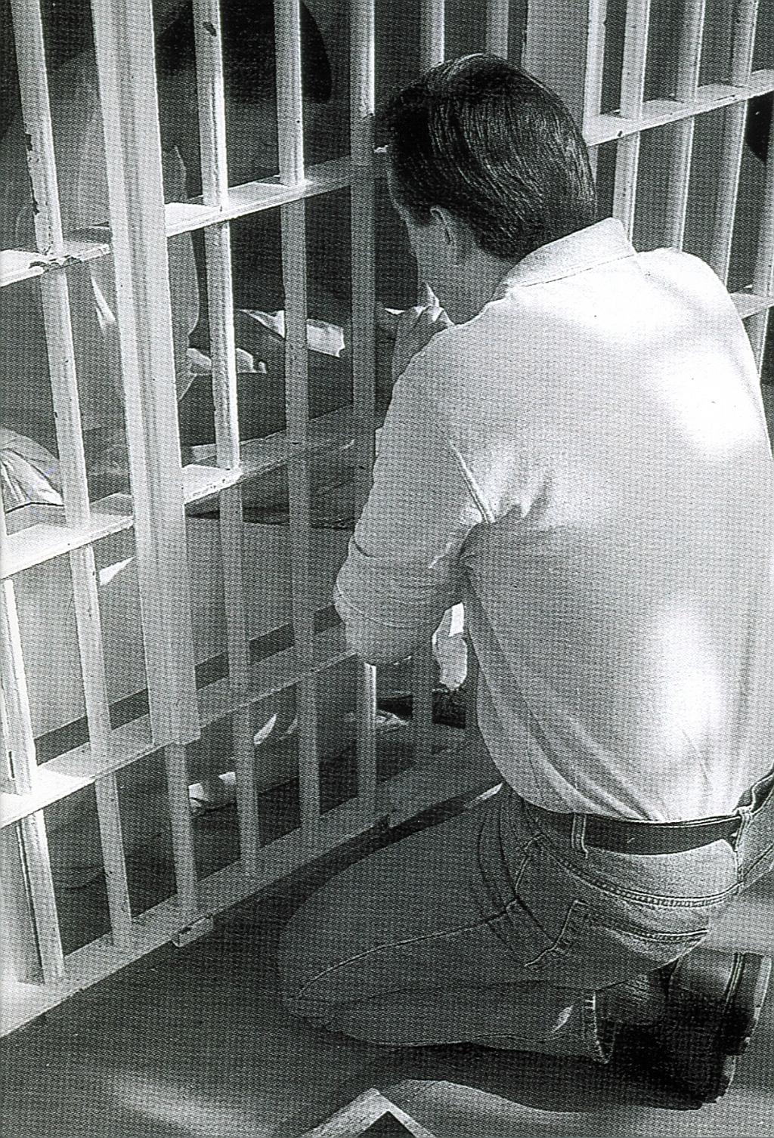

I can honestly say that some of these individuals are reached. And God’s Word commands us to preach the Word in its entirety, with boldness and with no apologies for what it says.

Intentions & Wishes
We have gone to Bi-Monthly because there is too much to share. The intentions of this newsletter are to allow an understanding of jail & prison ministries. It is our intentions to get input from those incarcerated as well as those “free” to visit. Life experiences of the faith and fellowship from those locked up in the facilities are always desired to let others know of the value of “visitation”. I am certain that each of us have many stories of the miracles God has done in our lives.
Our wishes are that we would have a list of supportive churches that individuals might look forward to attending once released.
A list of services, such as housing, employment, and counseling services, as well as some individuals available for friendly fellowship are also much needed items.
God’s Word says if a man stumbles, how can he continue lest there be another to help him up. Ecc. 4:10 “For if they fall, the one will lift up his fellow: but woe to him [that is] alone when he falleth; for [he hath] not another to help him up.” Proverbs 24:17 “Rejoice not when thy enemy falleth, and let not thy heart be glad when he stumbleth:” John 11:10 “But if a man walketh in the night, he stumbleth, because there is no light in him.”

Please help us with input for this news letter as we strive to serve God. We appreciate any articles, testimonies, or input.
Letters that Express it All

These are actual quotes from some of the different incarcerated individuals. The names have been removed

Translated from Spanish

I am answering your letter as soon as I received it because I was so happy that you wrote to me. For me it was a blessing from God to receive a letter like the one you sent because frankly you lifted my spirits. . . . You know the other day that you came and you prayed for me and my wife ------ and my son ----- I stayed with an utmost peace. Thank you Lord.

True Inspiration

. . . It is so true that we fail to see God’s plan. It’s like we put Him on the back burner a lot of times. When actually He should be the front burner at all times. Heck, He’s the flame for all the burners!

Need for Change

. . . Keep doing what you have been doing, and you will get what you have been getting.

Conversion

Conversion is the wiping clean of the slate so a new process can “start.”

Close, but . . .(honesty)

"I would like you to know that I did take the prayer on Monday night serious and that I do have good intentions of accepting the Lord as my savior. I know that I still haven't truly devoted my self to our Lord so I would be lying to you if I told you that I was. But I also know that it is what I want to do for my self cause I feel in my heart that if I follow the Lord that I will find a better life and happiness."
Please pray for individuals like this, that the Lord will lead them to a true commitment.

Fellowship

We would like to keep a listing of locations for fellowship that welcomes previous incarcerated individuals. Please feel free to let us know of those available. We also cherish letters from inmates or relatives to the churches to let us know how we are doing

CHAINBREAKERS
Every Tuesday
Visalia First Assembly
3737 S. Akers
Visalia, CA.
Room 8 – 7:00 p.m.
733-9070 ext. 131

Calvary Chapel Visalia
11720 Avenue 264
Visalia, CA. 93277
687-0220

Visalia First Baptist
1100 S. Sowell
Visalia, CA. 93277
732-4787

Church of the Nazarene
3333 W. Caldwell Avenue
Visalia, CA 93277
734-1117

Praise Center Church
503 N. Floral St.
Visalia, CA. 93291
733-2744

If you would like a church added,
Please contact us.

Addresses to contact our Ministry Volunteers

Bob
P.O. Box 6667
Visalia, CA. 93290

Rick
3737 S. Akers
Visalia, CA. 93277

When Satan reminds you of your past, remind him of his future.

God accepts you where you are, but loves you too much to leave you there.

Bible Study Lessons

SET FREE PRISON MINISTRY
Of Northern California
401 MacArthur Boulevard
San Leandro, CA. 94577-9801

Replenishing

God’s Word promises to restore the years of the locust, or more simply the years previously lost.

Joel 2:25 And I will restore to you the years that the locust hath eaten, the cankerworm, and the caterpillar, and the palmerworm, my great army which I sent among you.

Recommended Reading

For the new Christian, or the individual desiring to know God, we would like to recommend the following reading.

The Gospel of John – This is a great introduction of Christ’s walk on Earth.

The Book of Romans – This gives an introduction of many of the Bible stories shared and helps build familiarity of Christ’s plan for our lives.

The Purpose Driven Life by Rick Warren – 40 chapters will change your life in 40 days

Book of Proverbs – Read one chapter a day with the chapter read being the day of the month. This will allow the book to be read almost 12 times thru the year.

Ephesians 4 – 6 – This gives the pattern for life that we should live. All 7 S’s are displayed in these 3 chapters. We are given the purpose of the gifts, changing our character, husband/wife/family relationships, and the type of life we are to live and display.

Men’s Relational Toolbox – Another fine work by Gary Smalley with both of his sons adding to this book. This book avoids “male bashing” but rather teaches men to use and modify the inner tools they have to improve their relationships.

Don’t Give Up


We are often tempted to give up before we see the results we desire in our lives. The bamboo farmers of Malaysia could teach us a lesson. It takes great wisdom and patience to cultivate a particular strain of a very valuable bamboo. How do they do it? In the first year, they plant the seed, water, and fertilize it. Nothing visible happens. In the second year, they continue to water and fertilize. Nothing visible happens in the second year either. In the third year, water and fertilizer are even more necessary, yet nothing happens. There is absolutely no visible growth. In the fourth year, they do it all again. And again, nothing happens. Then, in the fifth year, they diligently water and fertilize, and the bamboo grows 90 feet in 30 days - not 9 inches, but 90 feet. This plant grows from nothing to the height of a nine-story building. The lesson for us: Don't grow weary in well doing, for in the end, there will be a harvest. In the end, it will come to pass.
Tools of Ministry (Part 4)

Vol. 4 & 5 newsletters we did part 1 & 2 of the tools of ministry. In the past we discussed such tools as;
A pair of Python Boots


A handcrafted one-of-a-kind car,

Skydiving,


And Rock climbing
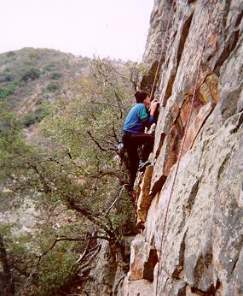

Now we will try to gibe some other tools that we can use to minister and witness to others. Being able

Wedding Ring
“With this ring I thee wed” brings many thoughts to us.


The wedding ring is given as a sign of a covenant with the spouse. How do we do with our commitment to our spouse? When describing the relationship of us with Christ, we are often referred to as the bride of Christ. When talking with someone, look at your wedding ring and start the conversation of “Do you know wqhat this ring stand for?” You can continue by saying “This reminds me of the vow and covenant I made with my spouse. Did you know that as a Christian, we have a covenant with Christ?” Explain that as we look at our wedding rings, we need to also be reminded that we are the bride of Christ and evaluate how well we are doing with our vows. One of the things that troubled Christ was when he expressed “you have lost your first love.”

Your Own Experiences

How about writing and sharing some of the tools you may have used.
Sharing Your Testimony

There are 4 parts to an individual’s testimony;
- What my life was like before I met Jesus
- How I realized I needed Jesus
- How I committed my life to Jesus
- The difference Jesus has made in my life.

But in reality, those who believe in Jesus have the testimony of God in them; Each of us needs to periodically share our testimony with others. The importance is not what you have done, but what God is doing.

- Your testimony;
- Your life lessons
- Your godly passions
- the Good News

God will make all things new
What are some things I should finish once I start?
"For if we are faithful to the end, trusting God just as firmly as when we first believed, we will share in all that belongs to Christ."
Hebrews 3:14
New life in Christ. We must maintain the confident faith we had when we first believed.
Scripture is from the New Living Translation (Tyndale House Publishers, 1996).

Testimonies

(Following testimony is from an inmate; translated from Spanish))

Mr. Bob
I am sending you a response to your most welcome and most appreciated letter and because you wrote back to me. Thank you for the photo to the little girl, she looks so pretty with her little dolls.

Why, she looks like an angel of God. Children are God's angels. Mr. Bob, I hope that you understand my letter because I do not write very well. I am going to write you in regards to what my life was like and the things that have happened to me. Hopefully this testimony will touch someone's life because I expect Glory thru Jesus Christ our Lord and what he has brought me from and the kind of life I have led.
My name is ------------ and this is my testimony. For eight years I was lost in the life of drugs and that is what has led me to be in prison. The other day I awoke up from my sleep and what came to mind was my wife and my son ----- who are my life and a blessing from God. The days passed and many things crossed my mind. I remembered all that hurt I inflicted on upon my wife and my son and the other people. It lay very heavy on my heart and I had to talk to someone but I felt to ignorant to know what to do. I knew there was a God but it didn't dawn on me to speak to him. Now I know and remember the day that Jesus Christ came into my life.
First of all I want to tell you about the bad illness I had with fever. It was very, very bad and only with medicine and injections would it get better but Jesus Christ was my doctor. It was on Christmas Day at 3 o'clock in the morning and I had already had 3 days being very sick here in prison. I had tonsillitis and much fever I had the worst painful headache that I could not sleep and felt like my head was going to explode from the pain. I could not even eat for 3 days due to my inflamed tonsils, fever and lying down from the tremendous pain. What came to my mind was that I was being punished because I had never experienced such terrible pain. I began to ask God, in the middle of my painful ordeal, to please forgive me of all that I had done to offend Him and others to deserve this punishment and for Him to take it away from me because it was too much to bear. It was then while speaking to God it dawned on me that painful headache had left me and I began to cry as I continued to ask for forgiveness laying down because I could not get on my knees from being so weak.
The main thing is that when I finished talking and confessing all of me I felt a healing in my heart and did not even remember falling into a most restful sleep. After the 3 days without eating, not resting and distressed with pain, I awoke very early without pain, without fever although my body was drenched from the sweat but very hungry even though weak I had Jesus Christ in my heart. God gave me a brand new heart.
Now that God has given me a new opportunity and new life I will not abandon Him because he never abandoned me. Even though I was what I was he loves me and I love my wife ------ and my son ----- who are a blessing from God to me and more precious is the gift that He has given me of a new life. The old Me died so a new Me could be born with a new heart that our Lord Jesus Christ gave me.
It is almost my time to be released God willing. I will be out on ---------- and I will be happy to be with my wife and son. I have a beautiful wife and a precious 2 year old and I love them very much. Now I have a treasure in my heart.
My desire with the Lord's guidance is to be obedient and share the word of God and it will have to start with my own family. Then it will be Christ who is my guiding Light.
I still have much to let you know about what God is to me in my life. I could not even express in words the magnificence of God's love and how much he has for all of us.
May God bless you and your family,

The Father, son and a friend

After a few of the usual Sunday evening hymns, the church's pastor slowly stood up, walked over to the pulpit and, before he gave his sermon for the evening, briefly introduced a guest minister who was in the service that evening. In the introduction, the pastor told the congregation that the guest minister was one of his dearest childhood friends and that he wanted him to have a few moments to greet the church and share whatever he felt would be appropriate for the service. With that, an elderly man stepped up to the pulpit and began to speak. "a father, his son, and a friend of his son, were sailing off the pacific coast." he began. "when a fast approaching storm blocked any attempt to get back to the shore. The waves were so high, that even though the father was an experienced sailor, he could not keep the boat upright and the three were swept into the ocean as the boat capsized." the old man hesitated for a moment, making eye contact with two teenagers who were, for the first time since the service began, looking somewhat interested in his story. The aged minister continued with his story, "grabbing a rescue line, the father had to make the most excruciating decision of his life: to which boy would he throw the other end of the lifeline. He only had seconds to make the decision. The father knew that his son was a Christian and he also knew that his son's friend was not. The agony of his decision could not be matched by the torrent of waves. As the father yelled out, 'i love you, son!' he threw out the life line to his son's friend. By the time the father had pulled the friend back to the capsized boat, his son had disappeared beneath the raging swells into the black of night. His body was never recovered. By this time, the two teenagers were sitting up straight in the pew, anxiously waiting for the next words to come out of the old minister's mouth. "the father," he continued, "knew his son would step into eternity with Jesus and he could not bear the thought of his son's friend stepping into an eternity without Jesus. Therefore, he sacrificed his son to save the son's friend.
How great is the love of god that he should do the same for us. Our heavenly father sacrificed his only begotten son that we could be saved. I urge you to accept his offer to rescue you and take a hold of the lifeline he is throwing out to you in this service." with that, the old man turned and sat back down in his chair as silence filled the room. The pastor again walked slowly to the pulpit and delivered a brief sermon with an invitation at the end. However, no one responded to the appeal. Within minutes after the service ended, the two teenagers were at the old man's side. "that was a nice story," politely stated one of them, "but i don't think it was very realistic for a father to give up his only son's life in hopes that the other boy would become a Christian." "well, you've got a point there," the old man replied glancing down at his worn bible. A big smile broadened his narrow face. He once again looked up at the boys and said, "it sure isn't very realistic, is it? But i'm standing here today to tell you that story gives me a glimpse of what it must have been like for god to give up his son for me. You see...i was that father and your pastor is my son's friend."

Too Blessed to be Stressed

• Love Worth Finding (Tuesday, June 01, 2004)
Fret not thyself because of evildoers, neither be thou envious against the workers of iniquity. For they shall soon be cut down like the grass, and wither as the green herb. Trust in the LORD, and do good; so shalt thou dwell in the land, and verily thou shalt be fed. Delight thyself also in the LORD; and He shall give thee the desires of thine heart. Commit thy way unto the LORD; trust also in Him; and He shall bring it to pass. And He shall bring forth thy righteousness as the light, and thy judgment as the noonday. Rest in the LORD, and wait patiently for Him. (Psalm 37:1-7)
I arrived at the airport one day and asked the skycap standing on the curb, "How's your day been going?" He looked me straight in the eye and with a grin about a mile wide, he said, "I am too blessed to be stressed." I like that because it summarizes what the psalmist was talking about.
The ignorant fret because they don't know enough. The educated fret because they know too much. The poor fret because they don’t have any money. The rich fret because they’re afraid they're going to lose what they have. The old fret because they’re facing death. The young fret because they're facing an unsure future. And yet God says to fret not, but how do we do that?
Trust In The Lord When Resources Vanish
Psalm 37:3 tells us to trust in the Lord and do good. The literal translation of this word "trust" is that you are face down on the ground with no visible means of support. Most of us have never been in that kind of position because we are able to see options. But, sometimes God puts us in a place where we don't have any options. The only thing we can do is trust God. Paul discovered this kind of trust in prison.
The second part of Psalm 37:3 says, To do good. Most people withdraw or retreat when things get tough. But, that is not what the psalmist tells us to do. We are to move forward and stay busy.
You see, God puts you in school. And God will keep you there until you pass the test. If you flunk out the first time, He'll enroll you again.
Delight In The Lord When Dreams Dissolve
Psalm 37:4 says that if you delight yourself in the Lord that He will give you the desires of your heart. When our dreams dissolve it is tempting to fret. Why? Because our joy is threatened. The only answer is to find a source of joy that cannot be threatened, and that source is the Lord.
You see, the psalmist exhorts us to delight in the Lord. Now if you delight yourself in anything other than the Lord, they are all subject to change. Malachi 3:6 tells us that the Lord never changes.
Is glorifying God the chief desire of your heart – even when your dreams dissolve? Corrie Ten Boom said, "Look around and you'll be distressed. Look within, and you'll be depressed. Look to the Lord, and you’ll be at rest."
Commit Your Way To The Lord When Your Lifestyle Is Threatened
The American lifestyle has gone through a dramatic transformation. But what does Psalm 37:5 tell us to do when our lifestyle is threatened? "Commit thy way unto the LORD; trust also in Him; and He shall bring it to pass."
The literal translation of the word "way" is "lifestyle." It has the idea of a well-traveled path. Now, the word "trust" has a different meaning than Psalm 37:3. It literally means to roll your way on the Lord – commit it to him.
Now if you do that, your standard of living may change, but not your standard of life. It's very important you understand that. There's a difference between a standard of living and a standard of life.
Rest In The Lord When God Seems Slow To Act
You can't rest until you have trusted, delighted, and committed your life to the Lord. This word "rest" literally has the idea of being silent before the Lord. It means you are not to murmur or complain.
You have to wait patiently for God. Psalm 30:5 says, "For His anger endureth but a moment; in His favour is life: weeping may endure for a night, but joy cometh in the morning." God's presence is like the sunrise – you can't hurry it up and you can't stop it.
When you rest in the Lord, you'll be too blessed to be stressed.

Vows of a Christian

The following are some aspects of the vow we have with Christ. Each will be discussed lightly and hopefully create a desire to study more of what God expects of us.

Following God
Prayer
Gathering
Chastity
Tithe

Following God
Many people will talk about wanting to receive Salvation. In reality, salvation is about giving our life to Christ and following God’s directing. It is not about doing our own thing and feeing like we can get away with it because we are forgiven. The scripture states that if we “repent” and ask for forgiveness, He is faithful to forgive us. Repenting can best be described by three words – “Stop – Turn – Follow.”

Prayer
Prayer is simply talking to God. The more we talk to someone the more we understand them. Many fear praying, but it is just as talking to a stranger for the first time. God should not be a stranger in our lives. How many of us can catch a friend and talk to them for hours. When was the last time you “really” spent time with the Lord?

Gathering
“Forsake not the gathering of yourselves” is commanded by God. This gathering is also commanded of us when Christ stated “upon the first day of the week”

Chastity
When we think of chastity, we think of purity. The scripture says in I Timothy 4:12 “Let no man despise thy youth; but be thou an example of the believers, in word, in conversation, in charity, in spirit, in faith, in purity.” In Philippians 4:8 it states “Finally, brethren, whatsoever things are true, whatsoever things are honest, whatsoever things are just, whatsoever things are pure, whatsoever things are lovely, whatsoever things are of good report; if there be any virtue, and if there be any praise, think on these.”

Tithe
“Wherein have we stolen from thee? In your tithes and offerings.” Mal. 3:8

“Give and it shall be given unto you; good measure, pressed down, and shaken together, and running over, shall men give into your bosom. For with the same measure ye mete withal it shall be measured to you again” Luke 6:38

Excuses of Sin

Sin is something we must confront head on. As with most things we hate to deal with, there is a tendency to “put off” dealing with sin in our lives. There are 5 reasons we make excuses and do not deal with sin.

Denial
When confronted with the fact that we may be living in sin, we will say “What sin?”

I John 1:10 If we say that we have not sinned, we make Him a liar, and His word is not in us.
He who says he is without sin, is a liar, and the truth is not within him.
I John 2:4 He that saith, I know him, and keepeth not his commandments, is a liar, and the truth is not in him.

I John 2:22 Who is a liar but he that denieth that Jesus is the Christ? He is antichrist, that denieth the Father and the Son.

Avoidance
Many times individuals will ignore the confrontation. Sometimes there is the avoidance by “Are you talking to me?” We need to avoid the situations of sin rather than avoiding the confrontation of sin. When confrontation comes our way out of love, we need to embrace the solutions and those bringing the solutions.

Blame Shift
Justification is often used to avoid dealing with sin. This justification, or blame shifting, is directed to others as the reason for our failing. How often do we hear, “It was because of the people I was with, they made me.”

Rationalize
Ever heard the phrase “Everybody does that?” We tend to rationalize that we are no worse than the majority of the people. We start doing comparisons of what others have done, and decide that we are not that bad. Rationalization can also be done in the opposite direction when we tend to pull up the “good things” a person has done in order to avoid confronting the sin in their life. Parents often will talk only about the accomplishments of their children and try to rationalize away the sin as being minor. In reality, sin is the major thing in our life that we must deal with.
Prov. 16:25 There is a way that seemeth right unto a man, but the end thereof [are] the ways of death.

Excuses
Another justification method is the one of excuses. Have you ever heard the statement, “Well you don’t understand what I have been through?” We make excuses because of environment, circumstances, troubled times, and even say “that is the way things were when I was growing up.”
Proper option would be “I did it” and am “guilty as charged.” God can only forgive those things that we are guilty of. If we do not admit guilt and turn away from the sins (repentance), God does not forgive. If we continue with our sins because of not being forgiven, we are not saved. The accepting of continuing on in the habitual sinning is different than the occasional sins we repent of.

